Products by - ClassicOutdoorMagazines.com
Custom Postcard (6x4) Order Form 2016
IDAHO – Rocky Mountain West
Your business address/information added to the vintage back
Minimum Order … 60 postcards-10 of each of 6 designs.
60 Postcards for $52 – FREE SHIPPING
120 Postcards for $84 – FREE SHIPPING

Organization __ __________________________________________________

Address ________________________________________________________

City ___________________________________________________________

State _____________________ Zip Code ____________________________

Contact Person & Phone ___________________________________________

Email _____________________________________________

6 Idaho Theme Cover-Art Postcards
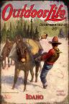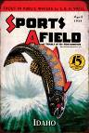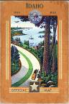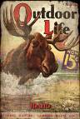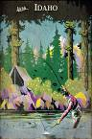

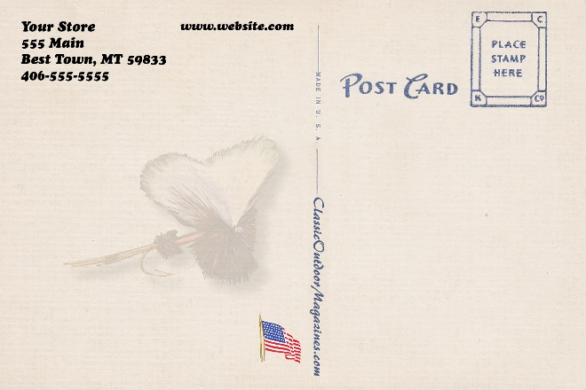
Add your custom text for the vintage back

Please call with questions. 406-552-2569
Email/mail form to: Bob@ClassicOutdoorMagazines.com
Bob Pitman
5732 Fox Trail
Florence, Montana 59833
Easy online text review & approval before printing
Business “Net 30” applies after Custom Postcards are received
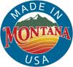
Web-based Ordering Information & Invoicing
Mail check to

