ClassicOutdoorMagazines.com
Custom Postcard (6x4) Order Form 2015
MONTANA – Rocky Mountain West
Your business address/information added to the vintage back
Minimum Order … 60 postcards-10 of each of 6 designs.
60 Postcards for $48 ($.80 each) plus shipping
120 Postcards for $78 ($.65 each) plus shipping

Organization ____________________________________________________

Address ________________________________________________________

City ___________________________________________________________

State _____________________ Zip Code ____________________________

Contact Person & Phone ___________________________________________

Email _____________________________________________

6 Montana Theme Cover-Art Postcards
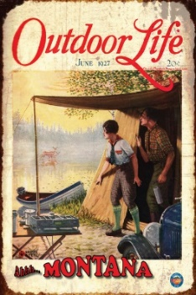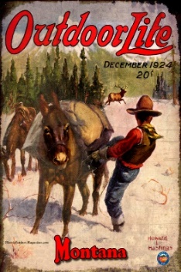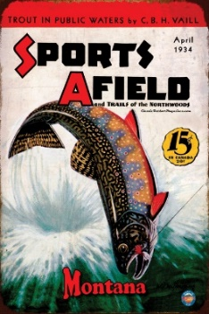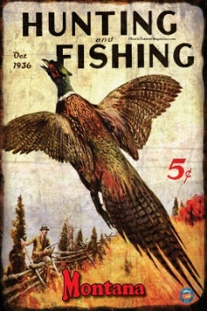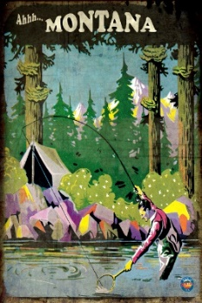

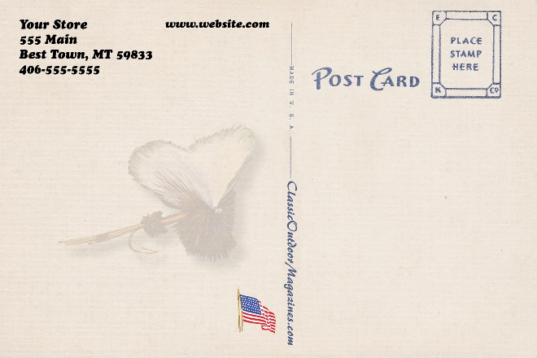
Add your custom text for the vintage back

Web-based Ordering Information & Invoicing
Please call with questions.
Email form to: Bob@ClassicOutdoorMagazines.com
Bob Pitman
Florence, Montana 406-552-2569
Easy online text review & approval before printing
Business “Net 30” applies after Custom Postcards are received

